Please complete the following template and return to your Venue contact no later than 30 days prior to the Venue Access date.
Print as many of the following page as you need and provide attachments as necessary to support the plan being effective (e.g. maps, photos, procedure, plans, insurances, licenses).

Event Organiser:
Event Name:
Postal Address: |  | Physical Address (if differs from Postal):
Contact Number: |  | Email:
Description of Event:

Location of event:
Start date: |  | Finish date:
Pack in date: |  | Pack Out date:
Anticipated Participants: |  | Anticipated Spectators:
Person in Charge of Event:
Risk Assessment completed by: |  | Contact number:
Venue Warden/Site Supervisor: |  | Contact number:

Emergency Procedures
Please ensure you include the following items

- Incident Command System – Flow charts of contacts to be used incase of emergency including name, title and contact number. A list of staff who will have radios
- Emergency Procedure – how report/recording of accidents will occur
- Evacuation Procedure
- Fire Extinguisher Locations
- Medical Team – First Aid details (including details of members and qualifications of personnel, what organisations are attending i.e. St Johns)
- Weather Policy – Consider the effect of wind/rain & UV protection
- Media Policy

Name of Event:
Date of Event |  |  |  | Site Supervisor:
Location of Event:
Hazards |  | Persons Affected | Control / Actions |  | Risk | Responsibility
Hazards |  | Persons Affected | Control / Actions |  | Risk | Responsibility

When creating your Risk Matrix the following should be taken into account:

- Any slipping, tripping or falling hazards
- Hazards relating to fire risks or fire evacuation procedures
- Any chemicals or other substances hazardous to health e.g. dust or fumes
- Moving parts of machinery
- Any vehicles/generators/fuel dumps on site
- Electrical safety
- Manual handling activities
- High noise levels
- Poor lighting, heating or ventilation
- Using public roads, vehicle movement, traffic
- Weather
- Alcohol/drugs
- Structures and loadings, marquees/tent suitability, inflatable equipment
Participants
- Accessibility needs – parking, toilet, venue accessibility
- Refreshments
- Information line
- Lost Children
- Animals

This list is by no means exhaustive and care should be taken to identify any other hazards associated with the activities at the event. For more information and advice contact the Work Safe NZ – 0800 030 040.

If you need help with your safety plan form please contact your Taupō District Council Event Coordinator.

Site MAP:
A useful site map includes a grid to enable all event team members to identify their location. The grid also allows emergency services to locate specific areas of the venue with radio or mobile instructions.

Creating a site map Consider the following:
- Entry & Exit points
- Vehicle access paths
- Parking
- Food & Vendor sites
- First aid posts
- Emergency Vehicle Access during an event
- Seating
- Lost & Found
- Safety fencing
- Rubbish bins
- Centre for emergency services
- Media Centre
- Pedestrian routes
- Stage locations
- Communication centre
- Rest areas
- Toilets
- Water outlets
- Information centre
- Security & police locations
- Details of Volunteer or marshals
- Evacuation points

In this section you are required to include the all Permits, License & Templates.
Some examples of things to include are Your Company’s Health & Safety Policy, Scaffolding tickets, Contractors Agreement & Induction List, Volunteer Agreement & Induction List

For you convenience we have included the following documents:
- Taupō District Council Health & Safety Policy Statement 2016
- Near Miss Card
- Incident report – All event organiser shall complete an incident report for all major incidents and provide a copy to the TDC Event Manager within 48 hours

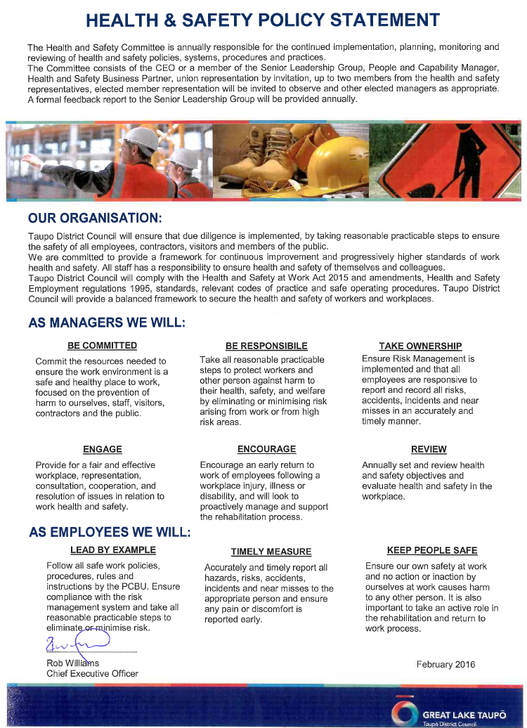

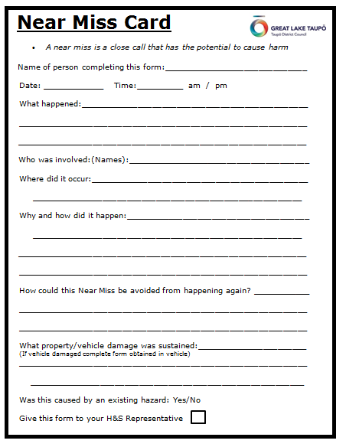

Injured Person Name:  ……………………………  ….……………………….. | DOB:…………………….  Male / Female  Ph:………………. | Address: | Injury location:  eg head, arm, body | Injury Type:  eg cut, burn, abrasion

Type of incident: | ◻ Injury ◻ Incident ◻ At Risk Behaviour ◻ Illness
Category: | ◻ Minor Harm ◻ Serious Harm ◻ Fatality ◻ Vehicle involved
Severity Level: | 3 = High 2 = Medium 1 = Low |  | (please circle)
Reported by: | ◻ Employee ◻ Contractor ◻ Third Party |  |  | Date reported:
 | Name: |  |  | Position:
Location & Time of Incident |  | Incident Description
◻ Incident happened off site
Department
Location
Position
Supervisor
Incident Date
Incident Time
Started work Time

Injury Description:
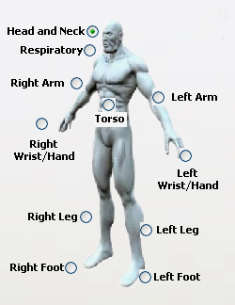

Treatment: | Medical Condition: | Days Off:
◻ No Treatment | ◻ Fully Fit | ◻ Lost Time Injury ____________days off
◻ First Aid | ◻ Restricted Duties
◻ Medical Treatment | ◻ Other
◻ Hospitalisation
Office Use Only  Entered in Vault | Yes/No
Serious Harm Procedure
Manager/Supervisor/Health & Safety Advisor to Contact WorkSafe NZ
Phone 0800 030 040 Date reported to WorkSafe: ____/_____/____

Name:
Reported to WorkSafe by:
Name:
WorkSafe representative name:
Date: Time:
Scene Held: Y/N (circle one) Scene Released: Y/N

Scene Released by who:
Name:
(WorkSafe, NZ Police, NZ Fire etc.)

Hazard Management Process
E.g. “Slide” AC Baths:
Hazard related to accident/incident:
Analysis/cause of accident/incident:

Name:
Initial investigation by:

Investigation date: ____/_____/____ Requires more investigation: Y/N..(circle one)

ID safety equipment used:

Did safety equipment fail: Y/N (circle one)

Equipment/machinery involved:
Preventative action required: Y/N (circle one) Action taken date: ____/_____/____
Action taken by: (Name)………………………………………………………..
Completed by:……………………………… Signature:……………………………………… Date: ____/_____/____
Sighted by
Head of Department: (Name)……………………………………………………………………………………….. Date: ____/_____/____
H&S Advisor
H&S Rep
Supervisor
Other:
Copied to (✓):

